1971
Ethyl iodide reacts with a solution of sodium hydroxide to give ethyl alcohol according to the equation.
CH₃CH₂I + OH⁻ → CH₃CH₂OH + I⁻
The reaction is first order with respect to both ethyl iodide and hydroxide ion, and the overall-rate expression for the reaction is as follows:
rate = k[CH₃CH₂I][OH⁻]
What would you do in the laboratory to obtain data to confirm the order in the rate expression for either of the reactants.
Answer:
The molar concentration of the hydroxide ion [OH⁻] can be determined by conducting the above reaction with a pH meter monitoring it. [OH⁻] = 1×10⁻¹⁴/-log pH. By measuring [OH⁻] over time and plotting ln[OH⁻] vs time, if a straight line results, the reaction is 1st order with respect to [OH⁻].

1972
2 A + 2 B → C + D
The following data about the reaction above were obtained from three experiments:
Experiment | [A] | [B] | Initial Rate of Formation of C (mole.liter⁻¹min⁻¹)
1 | 0.60 | 0.15 | 6.3×10⁻³
2 | 0.20 | 0.60 | 2.8×10⁻³
3 | 0.20 | 0.15 | 7.0×10⁻⁴
(a) What is the rate equation for the reaction?
(b) What is the numerical value of the rate constant k? What are its dimensions?
(c) Propose a reaction mechanism for this reaction.
Answer:
(a) rate = k [A]²[B]¹
(b) 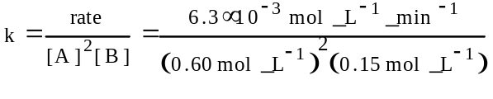
=0.12 L²mol⁻²min⁻¹
(c) A + A → A₂ (fast)
A₂ + B → C + Q (slow)
Q + B → D (fast)

1973 D
Some alkyl halides, such as (CH₃)₃CCl, (CH₃)₃CBr, and (CH₃)₃CI, represented by RX are believed to react with water according to the following sequence of reactions to produce alcohols:
RX → R⁺ + X⁻ (slow reaction)
R⁺ + H₂O → ROH + H⁺ (fast reaction)
(a) For the hydrolysis of RX, write a rate expression consistent with the reaction sequence above.
(b) When the alkyl halides RCl, RBr, and RI are added to water under the same experimental conditions, the rates are in the order RI > RBr > RCl.
Construct properly labeled potential energy diagrams that are consistent with the information on the rates of hydrolysis of the three alkyl halides. Assume that the reactions are exothermic.
Answer:
(a) rate = k [RX]
(b)
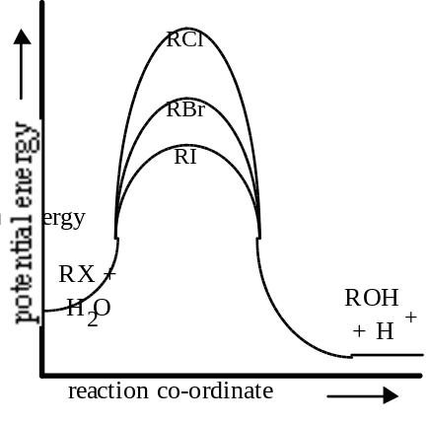

1974 D
A measure of the rate of a reaction is its half life. One method of determining the half life of a first order reaction is to plot certain appropriate data. Sketch a graph that illustrates the application of such a method. Label each axis with its name and appropriate units, and show how the half life can be obtained from the graph.
Answer:
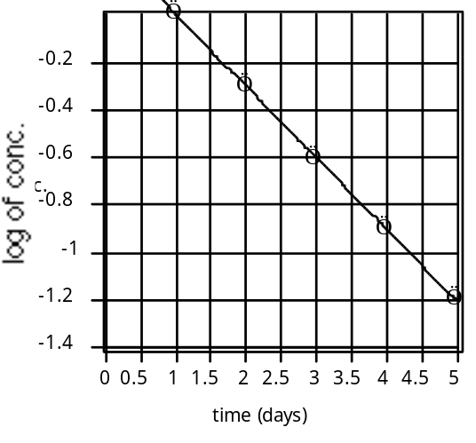
The slope of the line is k, t_{1/2} = 0.693/k

1975 B
2 NO(g) + O₂ → 2 NO₂(g)
A rate expression for the reaction above is:
^{-d[O}2]/_{dt} = k[NO]²[O₂]
 | ΔH_{f}°  kcal/mole | S°  cal/(mole)(K) | ΔG_{f}°  kcal/mole
NO(g) | 21.60 | 50.34 | 20.72
O₂(g) | 0 | 49.00 | 0
NO₂(g) | 8.09 | 57.47 | 12.39
(a) For the reaction above, find the rate constant at 25°C if the initial rate, as defined by the equation above, is 28 moles per liter-second when the concentration of nitric oxide is 0.20 mole per liter and the concentration of oxygen is 0.10 mole per liter.
(b) Calculate the equilibrium constant for the reaction at 25°C.
Answer:
(a) 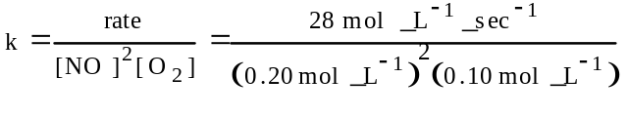
= 7000 L²mol⁻²sec⁻¹
(b) ΔG° = 2ΔG°_{NO2} - 2ΔG°_{NO} = (2)(12.39) - (2)(20.72)
= -16.66 kcal = -16660 cal = -69710 J
K =e^{-ΔG/RT} = e^{-[-69710/(8.314×298)]} = 1.65×10¹²

1976 D
Changing the temperature and no other conditions changes the rates of most chemical reactions. Two factors are commonly cited as accounting for the increased rate of chemical reaction as the temperature is increased. State briefly and discuss the two factors. Which of the two is more important?
Answer:
Energy factor - enough energy in the collision for the formation of an activated complex, where bonds are breaking and new ones forming. When temperature is increased, a greater number of molecular collisions possess enough energy to activate the reaction (activation energy).
Frequency of collisions increases - an increase in temperature makes particles move faster and collide more frequently, increasing the possibility of a reaction between them.
Energy factor is more important.

1977 B
2 NO(g) + O₂(g) ↔ 2 NO₂(g)
For the reaction above, the rate constant at 380°C for the forward reaction is 2.6×10³ liter²/mole²-sec and this reaction is first order in O₂ and second order in NO. The rate constant for the reverse reaction at 380°C is 4.1 liter/mole-sec and this reaction is second order in NO₂.
(a) Write the equilibrium expression for the reaction as indicated by the equation above and calculate the numerical value for the equilibrium constant at 380°C.
(b) What is the rate of the production of NO₂ at 380°C if the concentration of NO is 0.0060 mole/liter and the concentration of O₂ is 0.29 mole/liter?
(c) The system above is studied at another temperature. A 0.20 mole sample of NO₂ is placed in a 5.0 liter container and allowed to come to equilibrium. When equilibrium is reached, 15% of the original NO₂ has decomposed to NO and O₂. Calculate the value for the equilibrium constant at the second temperature.
Answer:
(a) 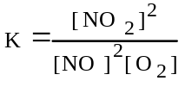
k_{for.}[NO]²[O₂] = k_{rev.}[NO₂]; K = ^{k}for. / k_{rev.}
K = 2.6×10³ / 4.1 = 6.3×10² M⁻¹
(b) R = k[NO]²[O₂] = (2.6×10³)(0.0060)²(0.29)
= 0.027 M/sec acceptable but R = ^{d[NO}2] /_{dt} = 0.054 M/sec better.
(c) [NO₂] = (0.20 - 15%) / 5L = 0.034 M
[O₂] = (15% of 0.20 / 2) / 5L = 0.0030 M
[NO] = (15% of 0.20) / 5L = 0.0060 M
K = (0.034)² / [(0.0060)²(0.0030)] = 1.1×10⁴ M⁻¹

1979 D
CH₃--NH₂ + H₂O → H₂S + CH₃--NH₂
The hydrolysis of thioacetamide is used to generate H₂S as shown by the equation above. The rate of the reaction is given by the rate law as follows:
rate = k[H⁺][CH₃--NH₂]
Consider a solution which is 0.10 molar in H+ and 0.10 molar in thioacetamide at 25° for each of the changes listed in (1), (2) and (3) below, state whether
(a) the rate of reaction increases, decreases or remains the same.
(b) the numerical value of k increases, decreases or remains the same.
(1) Sodium acetate is added to the solution.
(2) The solution is heated to 75°C.
(3) Water is added to the solution.
Give a brief explanation for each of your answers.
Answer:
(1) (a) Rate decreases. [H⁺] decreases because H⁺ reacts with CH₃COO⁻, a good base.
(b) k remains constant. k is a function of temperature only or is concentration independent.
(2) (a) Rate increases. The number - or fraction - of effective collisions increases.
(b) k increases. This change is predicted by the Arrhenius equation, k = A_{c}^{-E}a^{/RT}. [The explanation in (a) was also accepted.]
(3) (a) Rate decreases. Adding water decreases the concentration and results in a decrease in the frequency of collisions.
(b) k remains constant. Explanation is the same as in (1b).

1980 D
The decomposition of compound X is an elementary process that proceeds as follows:
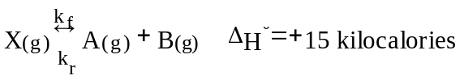
The forward reaction is slow at room temperature but becomes rapid when a catalyst is added.
(a) Draw a diagram of potential energy vs reaction coordinate for the uncatalyzed reaction. On this diagram label:
(1) the axes
(2) the energies of the reactants and the products
(3) the energy of the activated complex
(4) all significant energy differences
(b) On the same diagram indicate the change or changes that result from the addition of the catalyst. Explain the role of the catalyst in changing the rate of the reaction.
(c) If the temperature is increased, will the ratio ^{k}f/k_{r} increase, remain the same, or decrease? Justify your answer with a one or two sentence explanation. [k_{f} and k_{r} are the specific rate constants for the forward and the reverse reactions, respectively.]
Answer:
(a) 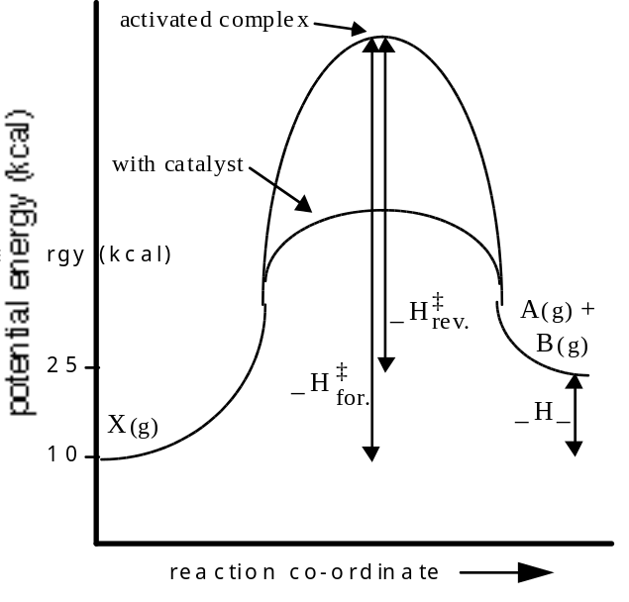
(b) [See above diagram]. The catalyst changes the mechanism and/or increases the number of molecules with sufficient energy to react.
(c) A temperature increases the ratio ^{k}f/k_{r}. Any one of the following applies:
(1) ^{k}f/k_{r} = K and LeChatelier’s principle applies.
(2) Boltzmann distribution graph.
(3) TΔS changes value for ΔG for the equation
(4) Forward reaction is endothermic so k_{f} will be increased more than k_{r} by temperature increase.
(5) Plot of ln k vs. ¹/_{T} has slope proportional to E_{a}; because E_{a(for.)} is greater than E_{a(rev.)}, k_{f} will increase more than k_{r}.

1981 B
A(aq) + 2 B(aq) → 3 C(aq) + D(aq)
For the reaction above, carried out in solution of 30C, the following kinetic data were obtained:
Experiment | Initial Conc. of Reactants  (mole.liter⁻¹) |  | Initial Rate of Reaction  (mole.liter^{-1.}hr⁻¹)
 | A_{o} | B_{o}
1 | 0.240 | 0.480 | 8.00
2 | 0.240 | 0.120 | 2.00
3 | 0.360 | 0.240 | 9.00
4 | 0.120 | 0.120 | 0.500
5 | 0.240 | 0.0600 | 1.00
6 | 0.0140 | 1.35 | ?
(a) Write the rate-law expression for this reaction.
(b) Calculate the value of the specific rate constant k at 30°C and specify its units.
(c) Calculate the value of the initial rate of this reaction at 30°C for the initial concentrations shown in experiment 6.
(d) Assume that the reaction goes to completion. Under the conditions specified for experiment 2, what would be the final molar concentration of C?
Answer:
(a) Rate = k [A]²[B]
(b) 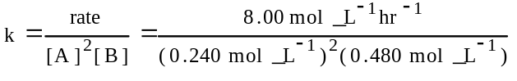
= 289 L²mol⁻²hr⁻¹
(c) Rate = k [A]²[B]
= (289 L²mol⁻²hr⁻¹)(0.0140 mol L⁻¹)²(1.35 mol L⁻¹)
= 0.0766 mol L⁻¹hr⁻¹
(d) According to the equation: 2 mol B reacts with 1 mol A, therefore, B is the limiting reagent, while only 0.006 mole/L of A reacts.
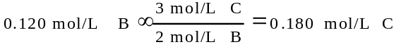

1983 C
Graphical methods are frequently used to analyze data and obtain desired quantities.
(a) 2 HI(g) → H₂(g) + I₂(g)
The following data give the value of the rate constant at various temperatures for the gas phase reaction above.
T (K) | k (litre/mol sec)
647 | 8.58×10⁻⁵
666 | 2.19×10⁻⁴
683 | 5.11×10⁻⁴
700 | 1.17×10⁻³
716 | 2.50×10⁻³
Describe, without doing any calculations, how a graphical method can be used to obtain the activation energy for this reaction.
(b) A(g) → B(g) + C(g)
The following data give the partial pressure of A as a function of time and were obtained at 100°C for the reaction above.
P_{A} (mm Hg) | t (sec)
348 | 0
247 | 600
185 | 1200
105 | 2400
58 | 3600
Describe, without doing any calculations, how graphs can be used to determine whether this reaction is first or second order in A and how these graphs are used to determine the rate constant.
Answer:
(a) Plot ln k vs. ¹/_{T}; E_{act} = -R (slope)
OR
Plot log k vs. ¹/_{T}; E_{act} = -2.303 R (slope)
(b) Plot ln P_{A} or log P_{A} vs. time
Plot ¹/_{PA} vs. time
If the former is linear, the reaction is 1st order. If the latter is linear, the reaction is 2nd order. If the reaction is 1st order, slope = -k₁ or -k₁ 2.303. If 2nd order, slope = k₂.

1984 B
For a hypothetical chemical reaction that has the stoichiometry 2 X + Y → Z, the following initial rate data were obtained. All measurements were made at the same temperature.
Initial Rate of Formation of Z, (mol.L^{-1.}sec⁻¹) | Initial [X]_{o}, (mol.L⁻¹) | Initial [Y]_{o}, (mol.L⁻¹)
7.0×10⁻⁴ | 0.20 | 0.10
1.4×10⁻³ | 0.40 | 0.20
2.8×10⁻³ | 0.40 | 0.40
4.2×10⁻³ | 0.60 | 0.60
(a) Give the rate law for this reaction from the data above.
(b) Calculate the specific rate constant for this reaction and specify its units.
(c) How long must the reaction proceed to produce a concentration of Z equal to 0.20 molar, if the initial reaction concentrations are [X]_{o} = 0.80 molar, [Y]_{o} = 0.60 molar and [Z]₀ = 0 molar?
(d) Select from the mechanisms below the one most consistent with the observed data, and explain your choice. In these mechanisms M and N are reaction intermediates.
(1) X + Y → M (slow)
X + M → Z (fast)
(2) X + X ↔ M (fast)
Y + M → Z (slow)
(3) Y → M (slow)
M + X → N (fast)
N + X → Z (fast)
Answer:
(a) Rate = k [X]º[Y]
(b) k = rate/[Y] = (0.00070mol.L^{-1.}sec⁻¹)/(0.10 mol.L⁻¹)
= 0.0070 sec⁻¹
(c) ln c_{o}/c = kt; ln 0.60/0.040 = (0.0070)t
t = 58 sec.
(d) Mechanism 3 is correct. The rate law shows that the slow reaction must involve one Y, consistent with mechanism 3.
Mechanisms 1 and 2 would involve both [X] and [Y] in the rate law, not consistent with the rate law.

1985 D
PCl₃(g) + Cl₂(g) ↔ PCl₅(g)
In the equation above, the forward reaction is first order in both PCl₃ and Cl₂ and the reverse reaction is first order in PCl₅.
(a) Suppose that 2 moles of PCl₃ and 1 mole of Cl₂ are mixed in a closed container at constant temperature. Draw a graph that shows how the concentrations of PCl₃, Cl₂, and PCl₅ change with time until after equilibrium has been firmly established.
(b) Give the initial rate law for the forward reaction.
(c) Provide a molecular explanation for the dependence of the rate of the forward reaction on the concentrations of the reactants.
(d) Provide a molecular explanation for the dependence of the rate of the forward reaction on temperature.
Answer:
(a) OR
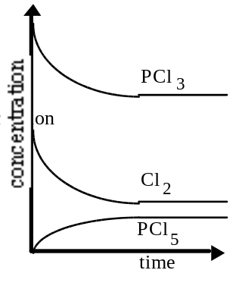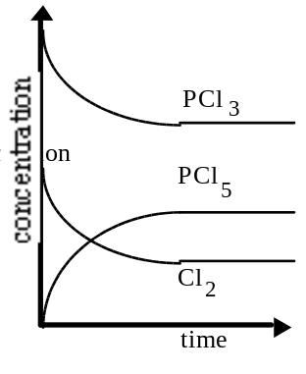
(b) Rate = k [PCl₃][Cl₂]
(c) Reaction requires effective collisions between molecules of PCl₃ and Cl₂. As concentrations of these molecules increase, the number of effective collisions must increase and the rate of reaction increases.
(d) The fraction of colliding molecules with the required activation energy increases as the temperature rises.

1986 D
The overall order of a reaction may not be predictable from the stoichiometry of the reaction.
(a) Explain how this statement can be true.
(b) 2 XY → X₂ + Y₂
1. For the hypothetical reaction above, give a rate law that shows that the reaction is first order in the reactant XY.
2. Give the units for the specific rate constant for this rate law.
3. Propose a mechanism that is consistent with both the rate law and the stoichiometry.
Answer:
(a) Order of reaction determined by the slowest step in the mechanism. OR
Order of reaction determined by exponents in the rate law. OR
Providing a counterexample where the coefficients in equation and exponents in rate law are different.
(b) 1. Rate = k [XY] or equivalent
2. k = ¹/_{time} or units consistent with studentÆs rate equation
3. Mechanism proposed should show:
a. steps adding up to the overall reaction
b. one step starting with XY
c. rate-determining step involving XY
example:
XY → X+ Y (slow)
XY + X → X₂ + Y (fast)
Y + Y → Y₂ (fast)

1987 B
2 HgCl₂(aq) + C₂O₄²⁻ → 2 Cl⁻ + 2 CO₂(g) + Hg₂Cl₂(aq)
The equation for the reaction between mercuric chloride and oxalate ion in hot aqueous solution is shown above. The reaction rate may be determined by measuring the initial rate of formation of chloride ion, at constant temperature, for various initial concentrations of mercuric chloride and oxalate as shown in the following table

Experi-ment | Initial [HgCl₂] | Initial [C₂O₄²⁻] | Initial Rate of Formation of Cl⁻  (mol.L^{-1.}min⁻¹)
(1) | 0.0836 M | 0.202M | 0.52×10⁻⁴
(2) | 0.0836 M | 0.404M | 2.08×10⁻⁴
(3) | 0.0418 M | 0.404M | 1.06×10⁻⁴
(4) | 0.0316 M | ? | 1.27×10⁻⁴
(a) According to the data shown, what is the rate law for the reaction above?
(b) On the basis of the rate law determined in part (a), calculate the specific rate constant. Specify the units.
(c) What is the numerical value for the initial rate of disappearance of C₂O₄²⁻ for Experiment 1?
(d) Calculate the initial oxalate ion concentration for Experiment 4.
Answer:
(a) Rate = k [HgCl₂][C₂O₄²⁻]²
(b) 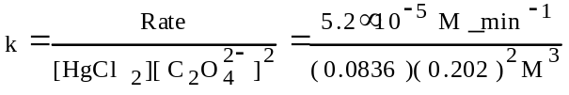
= 1.52×10⁻²M⁻²min⁻¹
(c) 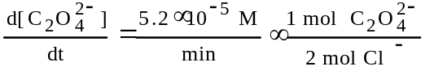
= 2.6×10⁻⁵M/min
(d) 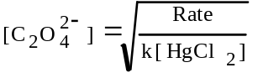
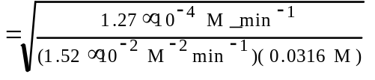
= 0.514 M

1989 D
C₂H₄(g) + H₂(g) → C₂H₆(g) ΔH° = -137 kJ
Account for the following observations regarding the exothermic reaction represented by the equation above.
(a) An increase in the pressure of the reactants causes an increase in the reaction rate.
(b) A small increase in temperature causes a large increase in the reaction rate.
(c) The presence of metallic nickel causes an increase in reaction rate.
(d) The presence of powdered nickel causes a larger increase in reaction rate than does the presence of a single piece of nickel of the same mass.
Answer:
(a) Effective concentrations are increased. So collision frequency is increased.
(b) Slight increase in collision frequency occurs. More molecules have enough energy that many more collisions have the necessary activation energy. Raises reaction rate a great deal.
(c) Catalytic nickel lowers the activation energy needed for a reaction. More often molecules have the needed energy when they collide. Reaction rate rises.
(d) Greater surface area with powdered Ni. More catalytic sites means a greater rate.

1990 D
Consider the following general equation for a chemical reaction.
A(g) + B(g) → C(g) + D(g) ΔH° reaction = -10 kJ
(a) Describe the two factors that determine whether a collision between molecules of A and B results in a reaction.
(b) How would a decrease in temperature affect the rate of the reaction shown above? Explain your answer.
(c) Write the rate law expression that would result if the reaction proceeded by the mechanism shown below.
A + B ↔ [AB] (fast)
[AB] + B → C + D (slow)
(d) Explain why a catalyst increases the rate of a reaction but does not change the value of the equilibrium constant for that reaction.
Answer:
(a) 1. The kinetic energy of the molecules - A certain minimum energy must be available for a reaction to occur. (activation energy)
2. The orientation of the molecules relative to one another - Even very energetic collisions may not lead to a reaction if the molecules are not oriented properly.
(b) 1. A decrease in temperature would decrease the rate.
2. Fewer molecules would have the energy necessary for reaction (fewer effective collisions).
(c) Rate = k [A][B]²
(d) 1. A catalyst increases the rate by providing an alternate pathway that has a lower activation energy.
2. The value of the equilibrium constant does not change, since a catalyst does not affect the energies (or concentrations) of the reactants and products.

1991 B
2 ClO₂(g) + F₂(g) → 2 ClO₂F(g)
The following results were obtained when the reaction represented above was studied at 25°C.
Experiment | Initial [ClO₂], (mol.L⁻¹) | Initial [F₂], (mol.L⁻¹) | Initial Rate of Increase of [ClO₂F],  (mol.L^{-1.}sec⁻¹)
1 | 0.010 | 0.10 | 2.4×10⁻³
2 | 0.010 | 0.40 | 9.6×10⁻³
3 | 0.020 | 0.20 | 9.6×10⁻³
(a) Write the rate law expression for the reaction above.
(b) Calculate the numerical value of the rate constant and specify the units.
(c) In experiment 2, what is the initial rate of decrease of [F₂]?
(d) Which of the following reaction mechanisms is consistent with the rate law developed in (a). Justify your choice.
I. ClO₂ + F₂ ↔ ClO₂F₂ (fast)
ClO₂F₂ → ClO₂F + F (slow)
ClO₂ + F → ClO₂F (fast)
II. F₂ → 2 F (slow)
2 (ClO₂ + F → ClO₂F) (fast)
Answer:
(a) [F₂] in expt. 2 is increased 4 times, the rate increases 4 times, ∴ 1st order in fluorine, rate = k [F₂]¹. In expt. 3, each reactant is doubled and the rate increases 4 times, ∴ 1st order in ClO₂,
rate = k [ClO₂]¹[F₂]¹
(b) 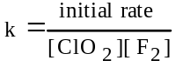
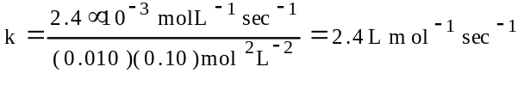
(c) 2 ClO₂ + F₂ → 2 ClO₂F
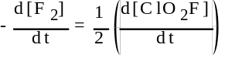
= (9.6×10⁻³)/2 = 4.8×10⁻³ mol L⁻¹ sec⁻¹
(d) for step 1, rate forward = rate reverse,
k_{f}[ClO₂][F₂] = k_{r}[ClO₂F₂]
[ClO₂F₂] = ^{k}f/k_{r}[ClO₂][F₂]
the overall rate is determined by the slowest step, step 2, ∴ rate = k₂[ClO₂F₂]
rate = k₂ ^{k}f/k_{r}[ClO₂][F₂] = k[ClO₂][F₂]

1992 D (Required)
H₂(g) + I₂(g) → 2 HI(g)
For the exothermic reaction represented above, carried out at 298K, the rate law is as follows.
Rate = k[H₂][I₂]
Predict the effect of each of the following changes on the initial rate of the reaction and explain your prediction.
(a) Addition of hydrogen gas at constant temperature and volume
(b) Increase in volume of the reaction vessel at constant temperature
(c) Addition of catalyst. In your explanation, include a diagram of potential energy versus reaction coordinate.
(d) Increase in temperature. In your explanation, include a diagram showing the number of molecules as a function of energy.
Answer:
(a) Initial rate will increase. Relate increase in concentration of H₂ to an increase in collision rate or to the rate law.
(b) Initial rate will decrease. Decrease in the concentration of reactants.
(c) Initial rate will increase. Activation energy is lowered.
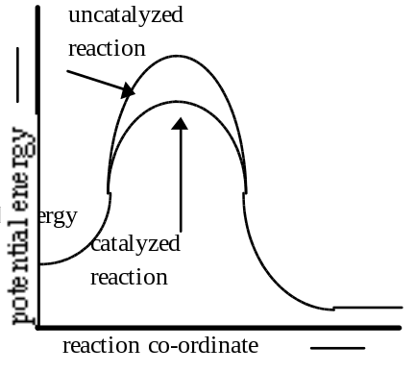
(d) Initial rate will increase. Maxwell-Boltzmann diagram
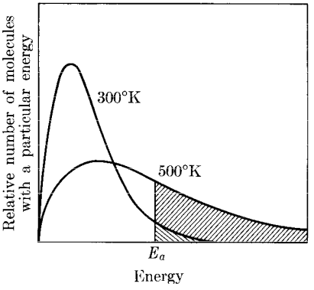

1994 B
2 NO(g) +2 H₂(g) → N₂(g) + 2 H₂O(g)
Experiments were conducted to study the rate of the reaction represented by the equation above. Initial concentrations and rates of reaction are given in the table below.
 | Initial Concentration (mol/L) |  | Initial Rate of Formation of N₂
Experiment | [NO] | [H₂] | (mol/L.min)
1 | 0.0060 | 0.0010 | 1.8 ×10⁻⁴
2 | 0.0060 | 0.0020 | 3.6 ×10⁻⁴
3 | 0.0010 | 0.0060 | 0.30 ×10⁻⁴
4 | 0.0020 | 0.0060 | 1.2 ×10⁻⁴
(a) (i) Determine the order for each of the reactants, NO and H₂, from the data given and show your reasoning.
(ii) Write the overall rate law for the reaction.
(b) Calculate the value of the rate constant, k, for the reaction. Include units.
(c) For experiment 2, calculate the concentration of NO remaining when exactly one-half of the original amount of H₂ had been consumed.
(d) The following sequence of elementary steps is a proposed mechanism for the reaction.
I. NO + NO ↔ N₂O₂
II. N₂O₂ + H₂ → H₂O + N₂O
III. N₂O + H₂ → N₂ + H₂O
Based on the data presented, which of the above is the rate-determining step? Show that the mechanism is consistent with
(i) the observed rate law for the reaction, and
(ii) the overall stoichiometry of the reaction.
Answer:
(a) (i) expt. 1 & 2 held [NO] constant while [H₂] doubled and the rate doubled, ∴ rate is 1st order with respect to [H₂].
expt. 3 & 4 held [H₂] constant while [NO] doubled and the rate quadrupled, ∴ rate is 2nd order with respect to [NO].
(ii) rate = k [H₂] [NO]² OR
(i) expt. 1, 1.8×10⁻⁴ = k (0.0060)^{m}(0.0010)^{n}
expt. 2, 3.6×10⁻⁴ = k (0.0060)^{m}(0.0020)^{n}
1.8×10⁻⁴/0.0010^{n} = 3.6×10⁻⁴/0.0020^{n} ; 0.0020^{n}/ 0.0010^{n} = 3.6×10⁻⁴/1.8×10⁻⁴
0.0020^{n}/0.0010^{n} = 2 where n = 1, ∴ [H₂] is 1st order
expt. 3, 0.30×10⁻⁴ = k (0.0010)^{m}(0.0060)^{n}
expt. 4, 1.2×10⁻⁴ = k (0.0020)^{m}(0.0060)^{n}
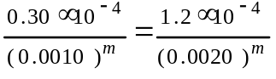
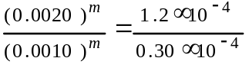
0.0020^{m}/0.0010^{m} = 4 where m = 2, ∴ [NO] is 2nd order
(b) using expt. 1,
1.8×10⁻⁴ mol/L.min = k 1.0×10⁻³ mol/L × (6.0×10⁻³ mol/L)²
k = 5.0×10³ L^{2.}mol^{-2.}min⁻¹
(c) [H₂] = (0.0020 - 0.0010) M = 0.0010 M
[NO] = (0.0060 - 0.0010) M = 0.0050 M
(d) step II is the rate determining step
(i) I. NO + NO 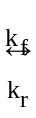 N₂O₂ (fast equilibrium)
[N₂O₄] = k_{f}/k_{r} [NO]²
II. N₂O₄ + H₂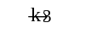 H₂O + N₂O (slow)
rate = 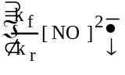(k₃ [H₂]), k_{f}/k_{r} × k₃ = k
rate = k [NO]² [H₂]
(ii) I NO + NO ↔ N₂O₂
II N₂O₂ + H₂ → H₂O + N₂O
III N₂O + H₂ → N₂ + H₂O
-------------------------------------------------
2 NO + 2 H₂ → 2 H₂O + N₂

1995 D
(I) A₂ + B₂ → 2 AB
(II) X₂ + Y₂ → 2 XY
Two reactions are represented above. The potential-energy diagram for reaction I is shown below. The potential energy of the reactants in reaction II is also indicated on the diagram. Reaction II is endothermic, and the activation energy of reaction I is greater than that of reaction II.
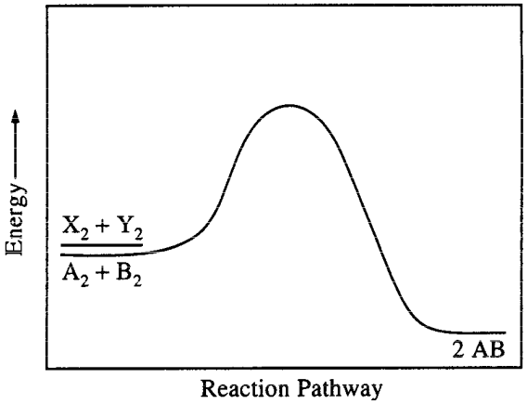
(a) Complete the potential-energy diagram for reaction II on the graph above..
(b) For reaction I, predict how each of the following is affected as the temperature is increased by 20°C. Explain the basis for each prediction.
(i) Rate of reaction
(ii) Heat of reaction
(c) For reaction II, the form of the rate law is rate = k[X₂]^{m}[Y₂]^{n}. Briefly describe an experiment that can be conducted in order to determine the values of m and n in the rate law for the reaction.
(d) From the information given, determine which reaction initially proceeds at the faster rate under the same conditions of concentration and temperature. Justify your answer.
Answer:
(a)
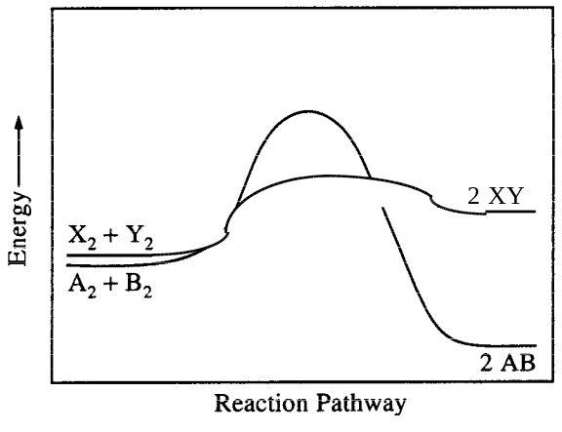
(b) (i) Rate increases. At temperature increases, the molecules move faster and collide more frequently resulting in more possible reactions in the same time span as before. Also, and more importantly, they have more kinetic energy which results in a higher percentage of molecules that have sufficient activation energy when they collide, resulting in more effective collisions and reactions.
(ii) Heat of reaction is increased. The energy of the reactants is increased so the ΔH (difference between reactants and products) is larger.
(c) Conduct a series of experiments in which the [Y₂] is kept constant and the [X₂] is varied by a specific amount and measure the initial reaction rate. Repeat keeping [X₂] constant and varying [Y₂] as in the table below.
Expt. # | [X₂] | [Y₂] | Initial reaction rate
1 | 1 | 1 | R₁
2 | 2 | 1 | R₂
3 | 1 | 2 | R₃
If R₁ = R₂ then m = 0, if R₂ = 2R₁ then m= 1, and if R₂ = 4R₁ then m = 2. Use similar logic to compare R₃ with R₁ and determine the value of n.
(d) Reaction II will initially be faster since it has the lower activation energy, a higher % of its molecules (since they are at the same temperature) will have sufficient energy to create the activated complex resulting in more effective collisions.
OR
It is not possible to determine which reaction has a faster rate without knowledge of other (pre-exponential) factors. It cannot be assumed these factors will be the same for X₂, Y₂ as for A₂, B₂, or that a similar mechanism is involved.

1996 D
The reaction between NO and H₂ is believed to occur in the following three-step process.
NO + NO → N₂O₂ (fast)
N₂O₂+ H₂ → N₂O + H₂O (slow)
N₂O + H₂ → N₂ + H₂O (fast)
(a) Write a balanced equation for the overall reaction.
(b) Identify the intermediates in the reaction. Explain your reasoning.
(c) From the mechanism represented above, a student correctly deduces that the rate law for the reaction is rate = k[NO]²[H₂]. The student then concludes that (1) the reaction is third-order and (2) the mechanism involves the simultaneous collision of two NO molecules and an H₂ molecule. Are conclusions (1) and (2) correct? Explain.
(d) Explain why an increase in temperature increases the rate constant, k, given the rate law in (c).
Answer:
(a) 2 NO + 2 H₂ → N₂ + 2 H₂O
(b) N₂O₂ and N₂O; they are part of the mechanism but are neither reactants nor products in the overall reaction.
(c) conclusion (1) is correct; the sum of the exponents in the rate law (2 + 1) = 3, the overall order.
conclusion (2) is incorrect; the three steps in the mechanism are all bimolecular collisions.
(d) an increase in temperature increases the rate and since there is no increase in concentrations then the rate constant, k, has to increase.
OR explanation using energy and frequency of collisions
OR explanation using Arrhenius equation
OR explanation using Maxwell-Boltzmann diagrams and activation energy.

1997 B
2 A + B → C + D
The following results were obtained when the reaction represented above was studied at 25°C.
Experiment | Initial [A] | Initial [B] | Initial Rate of Formation of C (mol L⁻¹ min⁻¹)
1 | 0.25 | 0.75 | 4.3×10⁻⁴
2 | 0.75 | 0.75 | 1.3×10⁻³
3 | 1.50 | 1.50 | 5.3×10⁻³
4 | 1.75 | ? | 8.0×10⁻³
(a) Determine the order of the reaction with respect to A and to B. Justify your answer.
(b) Write the rate law for the reaction. Calculate the value of the rate constant, specifying units.
(c) Determine the initial rate of change of [A] in Experiment 3.
(d) Determine the initial value of [B] in Experiment 4.
(e) Identify which of the reaction mechanisms represented below is consistent with the rate law developed in part (b). Justify your choice.
1. A + B → C + M Fast
M + A → D Slow
2. B ↔ M Fast equilibrium
M + A → C + X Slow
A + X → D Fast
3. A + B Δ M Fast equilibrium
M + A → C + X Slow
X → D Fast
Answer:
(a) 1st order with respect to A, 1st order with respect to B.
Expt. 2: initial rate tripled compared to expt. 1
Expt. 2: [A] tripled compared to expt. 1.
Expt. 3: initial rate is 4x compared to expt. 2
Expt. 3: [B] is doubled compared to expt. 2 and [A] is double compared to expt. 2
OR
initial rate₁ = k₁[A₁]^{m} [B₁]^{n}
k₁[B₁]^{n} = initial rate₁/[A₁]^{m}
initial rate₂ = k₂[A₂]^{m} [B₂]^{n}
k₂[B₂]^{n} = initial rate₂/[A₂]^{m} k₁[B₁]^{n} = k₂[B₂]^{n}
initial rate₁/[A₁]^{m} = initial rate₂/[A₂]^{m}
0.75^{m}/0.25^{m} = 1.3×10⁻³/4.3×10⁻⁴ = 3.0/1 when m = 1
k₂ = initial rate₂/[A₂]¹[B₂]^{n}
k₃ = initial rate₃/[A₃]¹[B₃]^{n}
k₂ = 1.3×10⁻³/0.75[B₂]^{n} = 1.7×10⁻³/[0.75]^{n}
k₃ = 5.3×10⁻³/1.50[B₃]^{n} = 3.5×10⁻³/[1.50]^{n}
1.7×10⁻³/[0.75]^{n} = 3.5×10⁻³/[1.50]^{n}
[1.50]^{n}/[0.75]^{n} = 3.5×10⁻³/1.7×10⁻³ = 2.0/1 when n = 1
(b) rate = k [A]¹[B]¹; k = rate/[A][B]
k = 5.3×10⁻³ mol L⁻¹ min⁻¹/(1.50 mol·L⁻¹ × 1.50 mol·L⁻¹)
k = 2.4×10⁻³ L·mol ⁻¹·min⁻¹
(c) since there is a 2:1 ratio of A:C and since the formation of C is the disappearance of A then:
rate = - rate × 2 = -(5.3×10⁻³) × 2
= -1.1×10⁻² mol L⁻¹ min⁻¹
(d) rate = k [A]¹[B]¹; [B] = rate/k[A]
[B] = 8.0×10⁻³ M min⁻¹/(2.4×10⁻³ L·mol ⁻¹·min⁻¹ × 1.75 M)
= 1.9 M
(e) mechanism 2.
step 1: rate_{f} = rate_{r} ; k_{f} [B] = k_{r} [M]
[M] = k_{f}/k_{r} · [B]
step 2: rate = k₃ [M] [A] = k/k_{r} · k₃ [B] [A]
k/k_{r} · k₃ = k

1998 D
Answer the following questions regarding the kinetics of chemical reactions.
(a) The diagram below at right shows the energy pathway for the reaction O₃ + NO → NO₂ + O₂. Clearly label the following directly on the diagram.
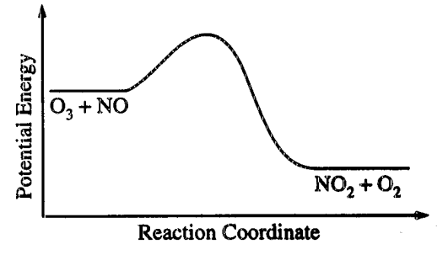
(i) The activation energy (E_{a}) for the forward reaction
(ii) The enthalpy change (ΔH) for the reaction
(b) The reaction 2 N₂O₅ → 4 NO₂ + O₂ is first order with respect to N₂O₅.
(i) Using the axes at right, complete the graph that represents the change in [N₂O₅] over time as the reaction proceeds.
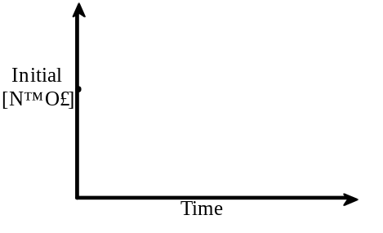
(ii) Describe how the graph in (i) could be used to find the reaction rate at a given time, t.
(iii) Considering the rate law and the graph in (i), describe how the value of the rate constant, k, could be determined.
(iv) If more N₂O₅ were added to the reaction mixture at constant temperature, what would be the effect on the rate constant, k ? Explain.
(c) Data for the chemical reaction 2A → B + C were collected by measuring the concentration of A at 10-minute intervals for 80 minutes. The following graphs were generated from analysis of the data.
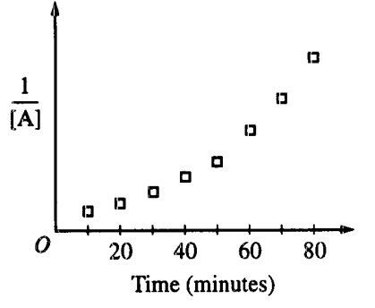
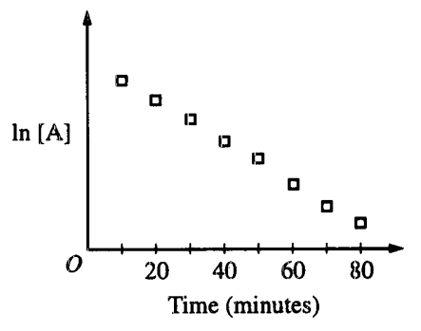
Use the information in the graphs above to answer the following.
(i) Write the rate-law expression for the reaction. Justify your answer.
(ii) Describe how to determine the value of the rate constant for the reaction.
Answer
(a) 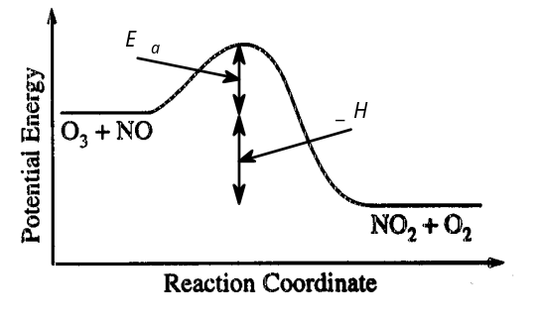
(b) i 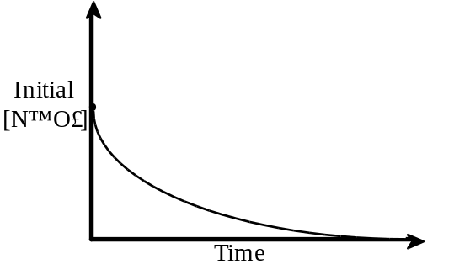
ii the rate at time, t, is the slope of the tangent to the curve at time t
iii since the reaction is 1st order:
ln[N₂O₃]_{t} - ln[N₂O₃]_{o} = -kt
k = 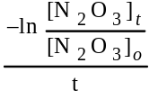
iv k would remain unchanged, it is temperature dependent, not concentration dependent.
(c)i since the graph of ln[A] is a straight line, this indicates that it its 1st order with respect to A, ∴, rate = k [A]
ii k = - slope of the straight line of the ln[A] vs. time graph

1999 B
3. 2 NO(g) + Br2(g) à 2 NOBr(g)
A rate study of the reaction represented above was conducted at 25ºC. The data that were obtained are shown in the table below.
Experiment | Initial [NO] (mol L–1) | Initial [Br2] (mol L-1) | Initial Rate of Appearance of NOBr (mol L–1 s–1)
1 | 0.0160 | 0.0120 | 3.24x10–4
2 | 0.0160 | 0.0240 | 6.38x10–4
3 | 0.0320 | 0.0060 | 6.42x10–4

(a) Calculate the initial rate of disappearance of Br2(g) in experiment 1.
(b) Determine the order of the reaction with respect to each reactant, Br2(g)and NO(g). In each case, explain your reasoning.
(c) For the reaction,
(i) write the rate law that is consistent with the data, and
(ii) calculate the value of the specific rate constant, k, and specify units.
(d) The following mechanism was proposed for the reaction:
Br2(g) + NO(g) à NOBr2(g) slow
NOBr2(g) + NO(g) à 2 NOBr(g) fast
Is this mechanism consistent with the given experimental observations? Justify your answer.
Answer
(a) Since the disappearance of 1 Br2 produces 2 NOBr, then the rate would be half as much or rate = -1.62x10–4.
(b) With respect to Br2: rate = k [NO]m[Br2]n
In expt. 2 the [Br2] is twice the concentration in expt. 1, as well, the initial rate of expt. 2 is twice the initial rate of expt. 1, while [NO] remains constant. Therefore, it is 1st order with respect to [Br2], n = 1.
With respect to NO: rate = k[NO]m[Br2]1
expt. 2: 6.38x10–4 = k (0.0160)m(0.024)
k =
expt 3: 6.42x10–4 = k (0.0320)m(0.0060)
k =
=
solving: m = 1.97 or m = 2
therefore, 2nd order with respect to [NO].
(c) (i) rate = k[NO]2[Br2]
(ii) k =
=
= 105 L2mol–2s–1
(d) No; since the rate determining step is the slowest step (and in this case, the first step), then the rate for this proposed mechanism depends only on the cencentration of the reactants in the first step and would be: rate = k[NO][Br2]

